**12 April 2019** **The Weekly Bulletin of Rotary Club of Kathmandu Mid-Town** **bc-26.4/019**

|  |
| --- |
| C:\Users\Public\Documents\RIP T1819_EN.png |

District: 3292 Web:www.rotarymidtown.org.np Club Id: 26776

**APRIL IS MATERNAL AND CHILD HEALTH** **MONTH**

Maternal and Child Health Care is also recognized as one of Rotary’s Six Areas of Focus.

Every day mothers risk their lives giving birth and millions of children die each year from treatable, preventable causes. At least 7 million children under the age of five die each year due to malnutrition, poor health care, and inadequate sanitation. To help reduce this rate, Rotary provides immunizations and antibiotics to babies, improves access to essential medical services, and supports trained health care providers for mothers and their children. Rotary’s projects ensure sustainability by empowering the local community to take ownership of health care training programs.

**Weekly Club Meeting # 1483 held on Saturday 30 Mar 2019 at Simpani Gairigaon Dhading:**

Field meeting at Simpani, Gairigaon, Dhading

Global Grant #1754006 the Simpani Lift Water project in partnership with RC Masan East, South Korea, was complete and in operation.

A group of Mid-Towners including President and IPP visited the project site, observed project in operation, and handed over the project to the local community in a special program held for the purpose.

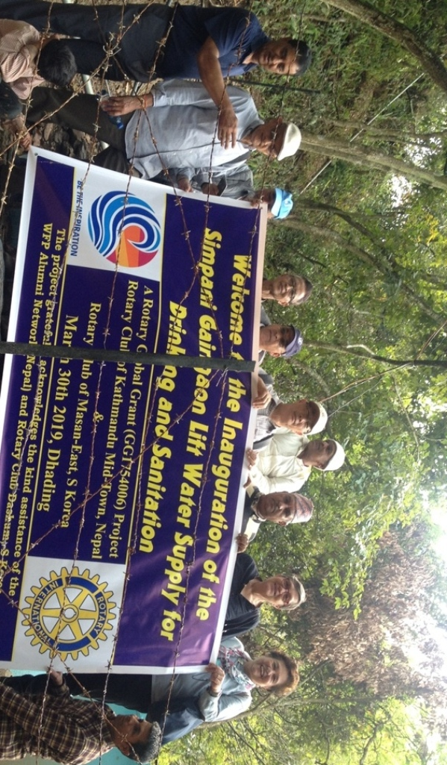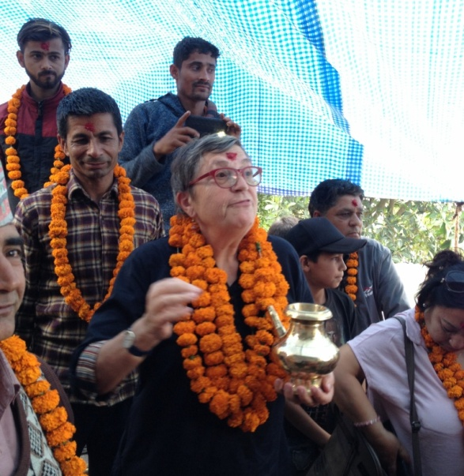

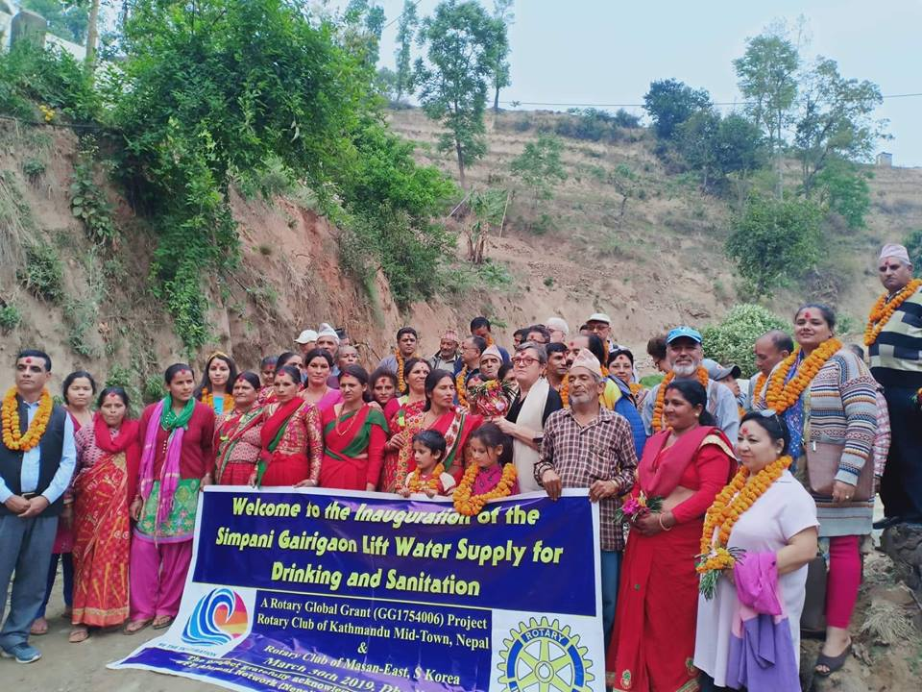

**Adhir Chipalu provides yet another donation:**

Adhir had his birthday celebration last month at Hotel Radisson. Adhir and his father, our Mid-Towner Govinda Chipalu, decided to give away whatever amount received in cash as his HBD gift for a good social cause. What would be better than helping poor school students of a village school. In coordination with IPP Bhairaja Panday, Project Director of Simpani Lift Water project and local project manager, a local school of Simpani picked up, having altogether 33 students enrolled. It was agreed with the school management that the money would be used for making school uniform for those 33 enrolled students, and whatever money left to be spent for stationaries for the students. Adhir handed over a packet of 33 envelopes, each envelope containing a sum of Rs 1,500 in cash, to one youngest student of the school on behalf of school management. At the end of the program Govind Chipalu informed that one envelope (one of the 33 envelopes just handed over) was especial, because it contained Rs 2,000. One student was to be lucky to receive Rs 500 more.

Thank you Govinda for inscribing exemplary culture! Other Mid-Towners will hopefully follow suit!

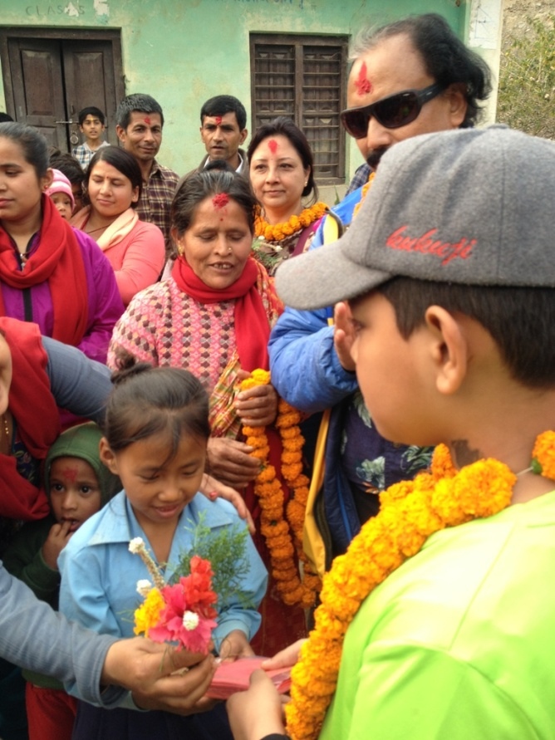 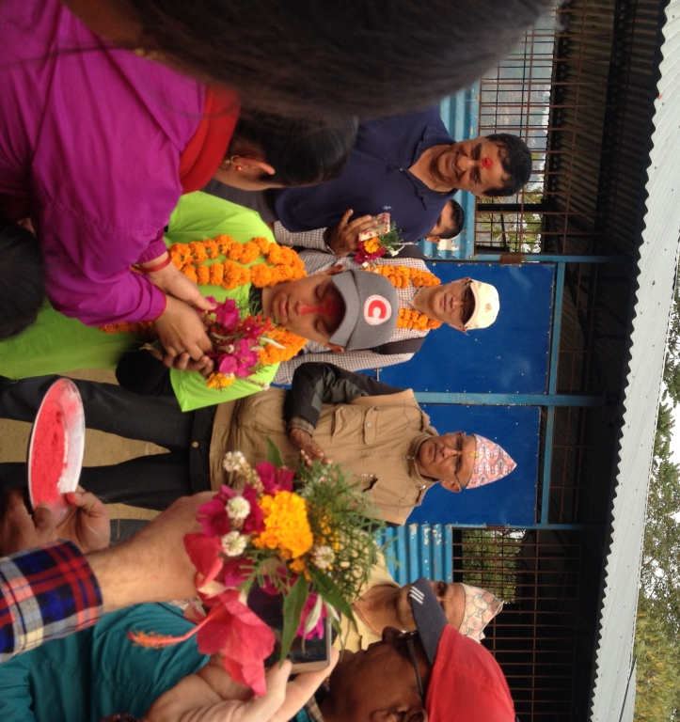

Adhir handing over 33 envelopes to one youngest student. A School teacher thanking Adhir for his great mind with a flower bouquet.

**Club Meeting # 1484 Friday 5 April**

Guest speaker, Dr Rownak Khan, UN Representative from Bangladesh, having 25 years of service in UN, shared her experiences on maternal health and child care.

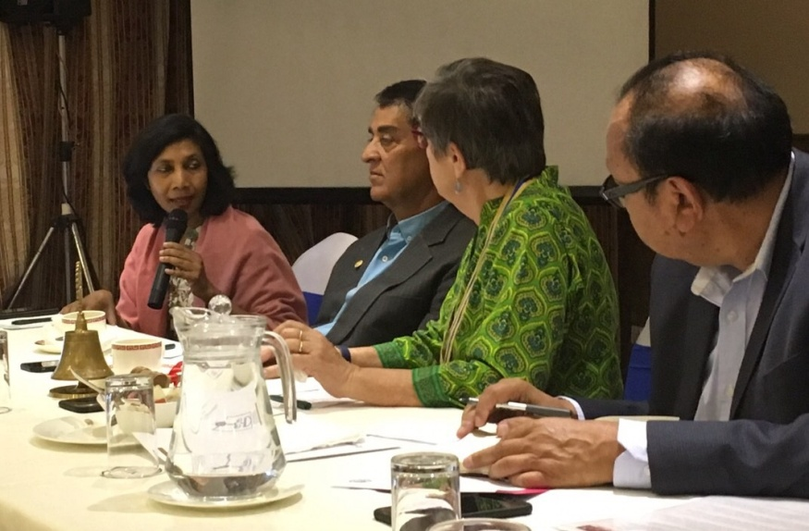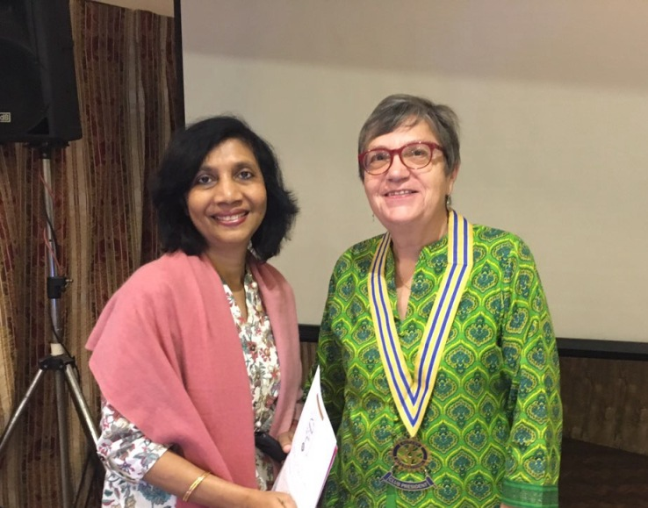

Dr Khan in the session Guest speaker with President Jo

**PE Neeva organized a Lunch Meeting of Board 2019-20:**

PE Neeva invited BoD 2019-20 members for a lunch at her residence on Saturday 6 April for strengthening fellowship and some interactions. Altogether 12 including Neeva participated. The interaction centered on Club plans/programs in the year, Rotary theme ‘Rotary Connects the World’, membership development, building partnership with organizations for successful Rotary year. For making the interactions interesting Neeva had some ‘funs’ in between, lucky draw, action groups, presentations etc, A nice buffet lunch was served after the program.

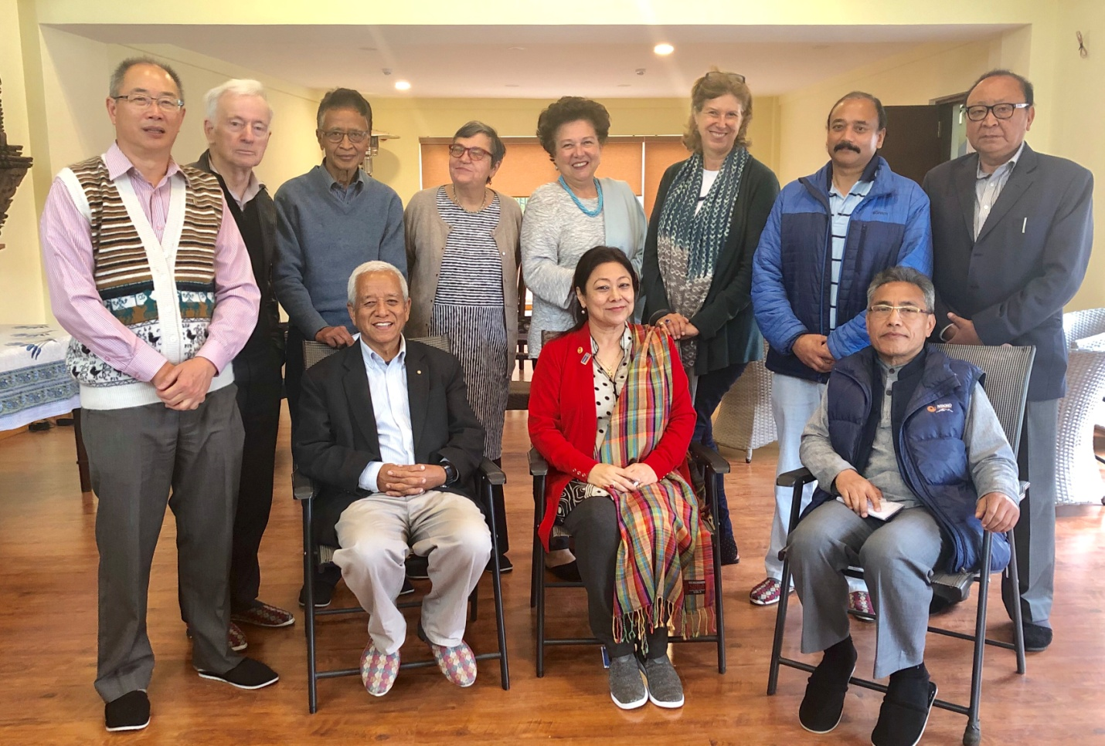

**People of Action, Small City Big Projects:**

**The Rotary Club of Ratlam** is mesmerizing the city of Ratlam (Madhya Pradesh, India) with its bunch of highly impressive projects and taking Rotary’s public image to a new high.

The little room called the *Aahar Kendra*, which is the club’s signature project being run from 1995, is bang opposite the Ratlam Civil Hospital. Mukesh Jain, past president of the club, explains that the food is being prepared for the relatives and attendants of the patients who are seeking treatment in this hospital. “Many of them travel long distances to bring their loved ones to the hospital and we make available this freshly made food - both lunch and dinner - to them at a mere Rs 5.” The meal includes two rotis, a sabzi, dal and rice … on their birthdays, anniversaries or other special occasions, Rotarians donate the sweet … …

Club’s another signature project is the dialysis centre (about 36 patients undergo dialysis every day here), Likewise, the Club owns a Rotary Hall (all the Rotary clubs in Ratlam meet here), and Rotary Garden (spread across a whopping one lakh sq ft of space, and with an open air gym for women) … …

*Read more on Rotary News, June 2018*

**If You Like It**

The International Exoplanets found orbiting Trappist-1 raise hope that the hunt for alien life beyond the solar system can start much sooner than previously thought.

A huddle of seven worlds, all close in size to Earth, and perhaps warm enough for water and the life it can sustain, has been spotted around a small, faint star in the constellation of Aquarius. The discovery, which has thrilled astronomers, has raised hopes that the hunt for alien life beyond the solar system could start much sooner than previously thought, with the next generation of telescopes that are due to switch on in the next decade.

It is the first time that so many Earth-sized planets have been found in orbit around the same star, an unexpected haul that suggests the Milky Way may be teeming with worlds that, in size and firmness underfoot at least, resemble our own rocky home.

The planets closely circle a [dwarf star named Trappist-1](https://www.theguardian.com/science/2016/may/02/could-these-newly-discovered-planets-orbiting-an-ultracool-dwarf-host-life), which at 39 light years away makes the system a prime candidate to search for signs of life. Only marginally larger than Jupiter, the star shines with a feeble light about 2,000 times fainter than our sun.

*Read more on https://www.theguardian.com/science*

**A THOUGHT FOR THE DAY**

“When I was DG, for all the 12 issues of GML, you will not find any pictures of mine or my wife. Because I’ve always believed that people want to see their pictures and not yours.”

*PDG Prem Bhalla (District 3080), an avid writer, nearly 50 books*

On Lighter Side:

A group of blondes in a class were given the assignment to measure the height of a flagpole. So they went out to the flagpole with ladders and tape measures, and they were falling off the ladders, dropping the tape measures, the whole thing was just a mess.

While it was going on, an engineer came along and saw what they were trying to do. He walked over, pulled the flagpole out of the ground, laid it flat, measured it from end to end, gave the measurement to one of the blondes and walked away.

After the engineer was gone, one blonde turned to another and laughed.

"Isn't that just like an engineer, we're looking for the height and he gave us the length!”



If there's one thing Rotary has always excelled at, it's diversity. In the past, that often meant

diversity of profession, nationality, and outlook. We've made great strides when it comes to

diversity of age and gender, and as we welcome more Rotaractors into our organization,

we'll become even stronger.

**RI President Barry Rassin**

Please send information on club activities, progress reviews on service projects, relevant photos etc to:

BC Editor: RR Shrestha email: rryesrr@gmail.com

## 12 April 2019 The Weekly Bulletin of Rotary Club of Kathmandu Mid-Town bc-26.3/019